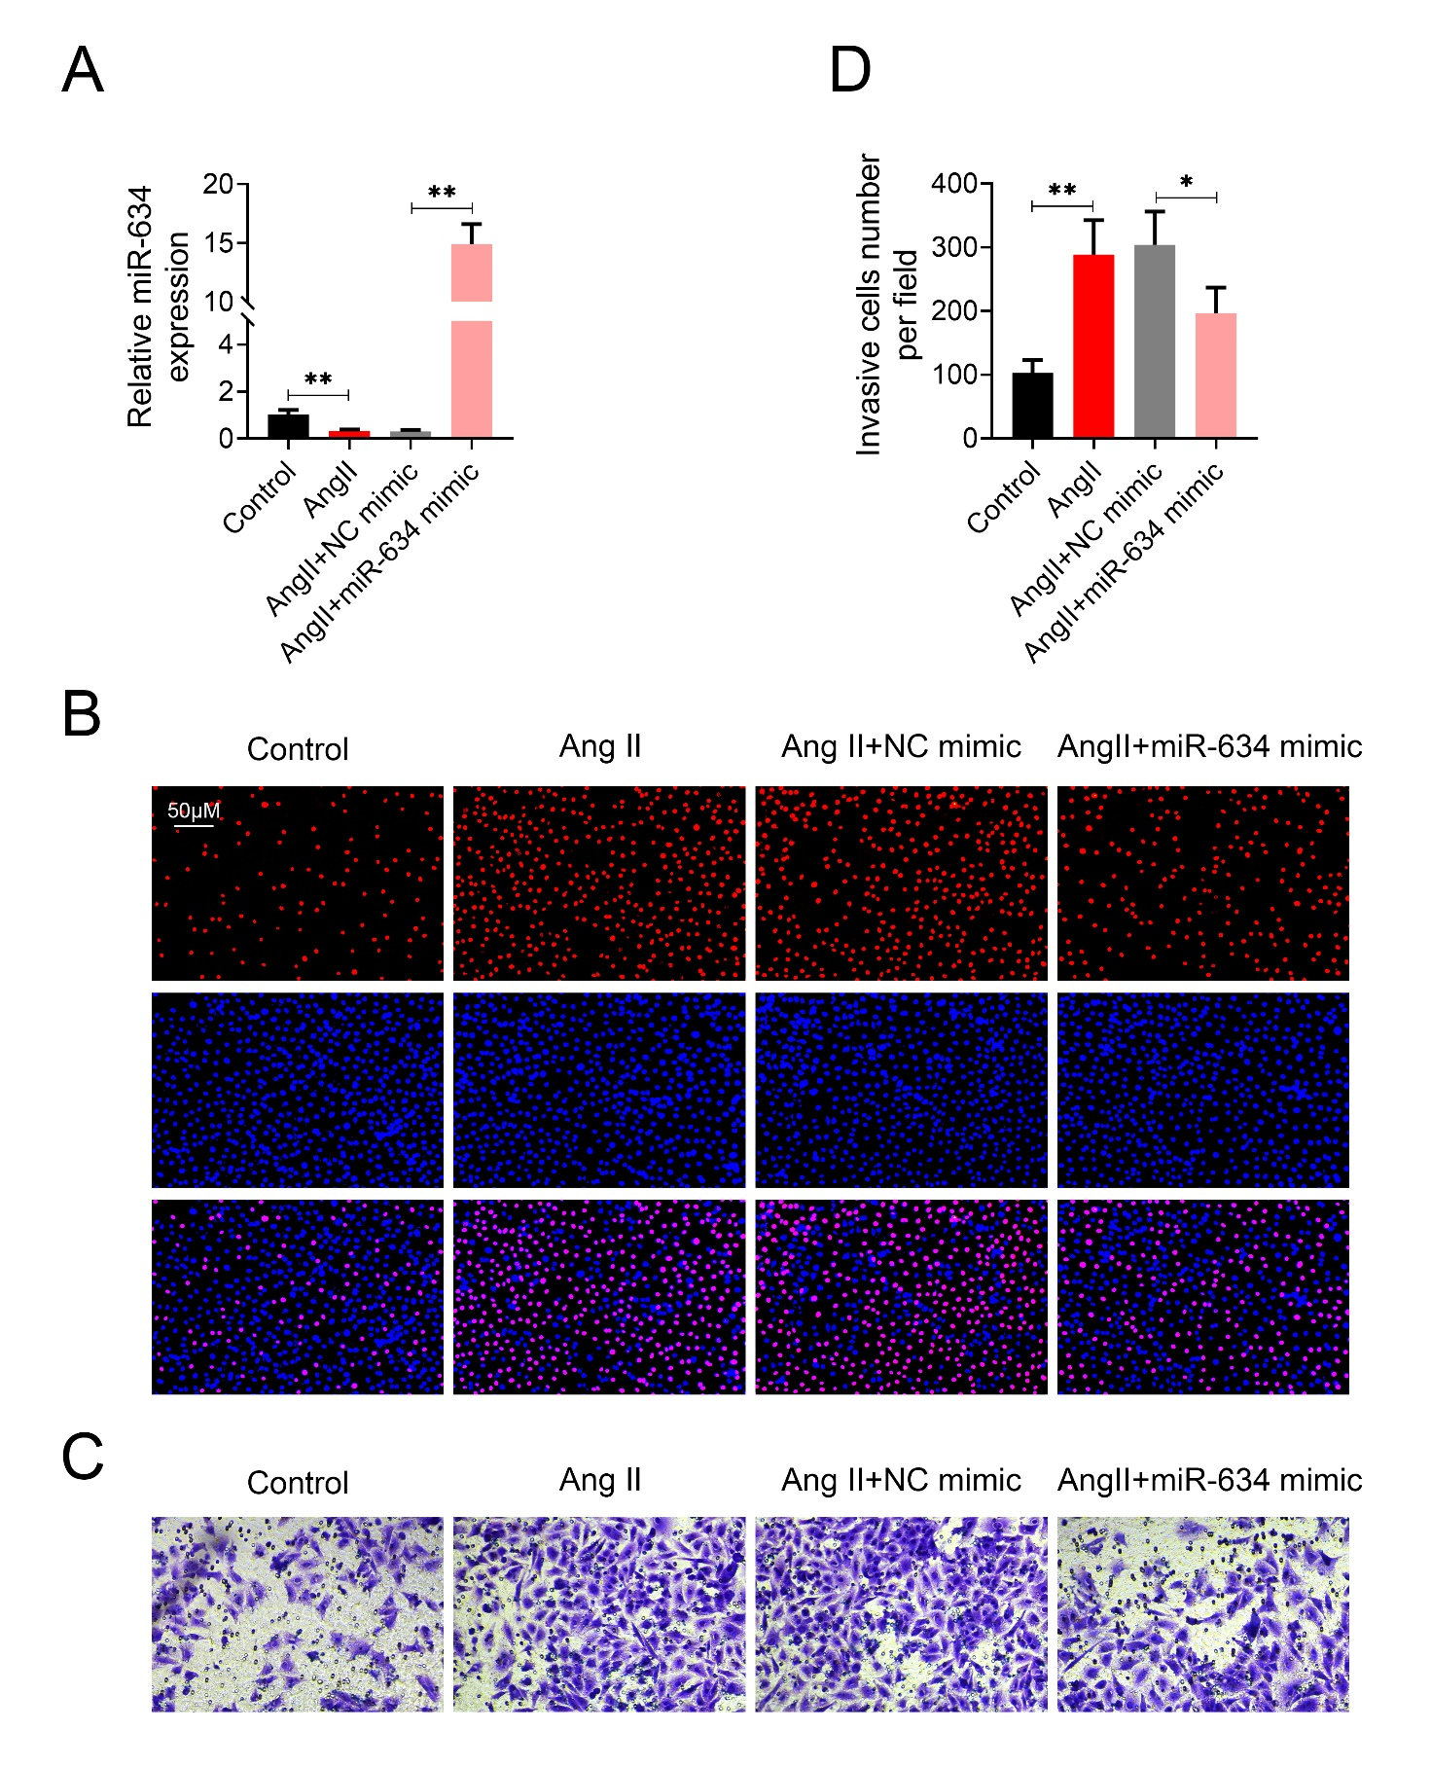
Supplementary Fig. 1. MiR-634 suppressed Ang II-induced HVSMCs proliferation and migration.
(A) Transfection efficiency of miR-634 mimic in HVSMCs was detected by qRT-PCR. (B) Effect of miR-634 on cell proliferation of HVSMCs with Ang II treatment. (C) Effect of miR-634 on cell migration of HVSMCs with Ang II treatment. (C) Effect of miR-634 on invasion cells number of HVSMCs with Ang II treatment. *, **, p < 0.05, p < 0.01. NC mimic: negative control of miR-634 mimic. Scale bars: 50 μm.

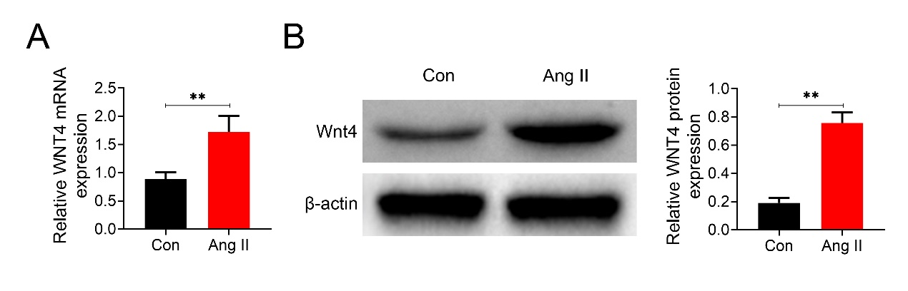
Supplementary Fig. 2. Treatment of 2 μM Ang II for 12 hours increased mRNA (A) and protein (B) expression of Wnt4 in HASMCs. ** p < 0.01.

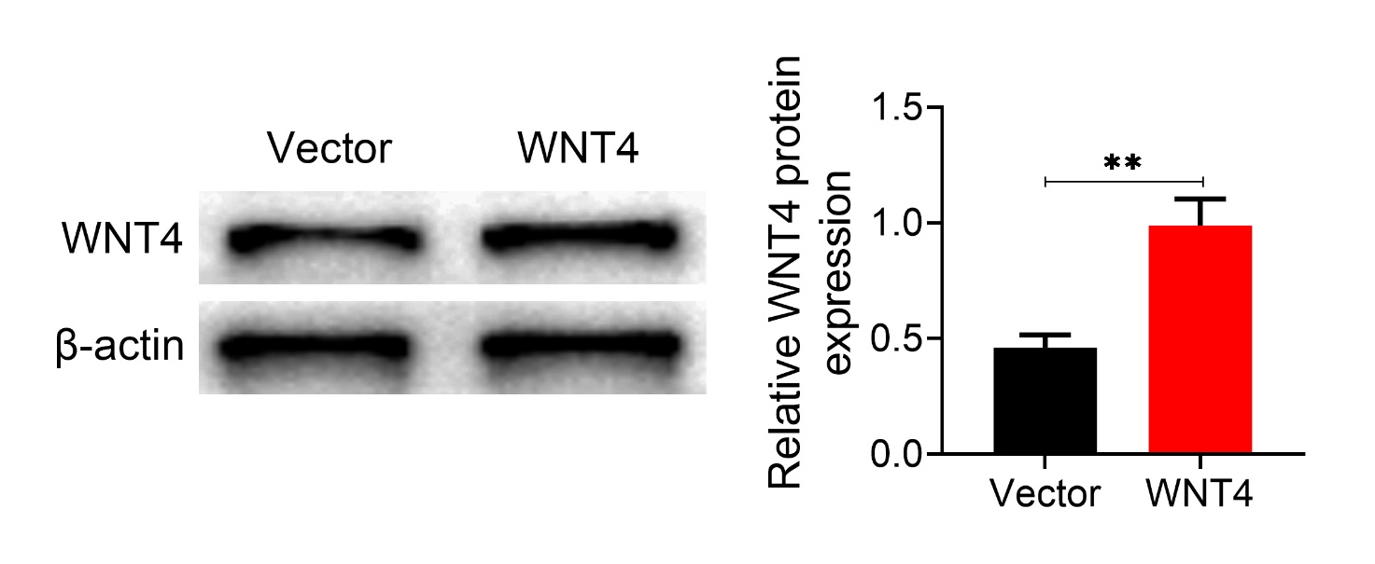
Supplementary Fig. 3. Transfection with pcDNA-Wnt4 in Ang II-induced HASMCs increased protein expression of Wnt4. ** p < 0.01.

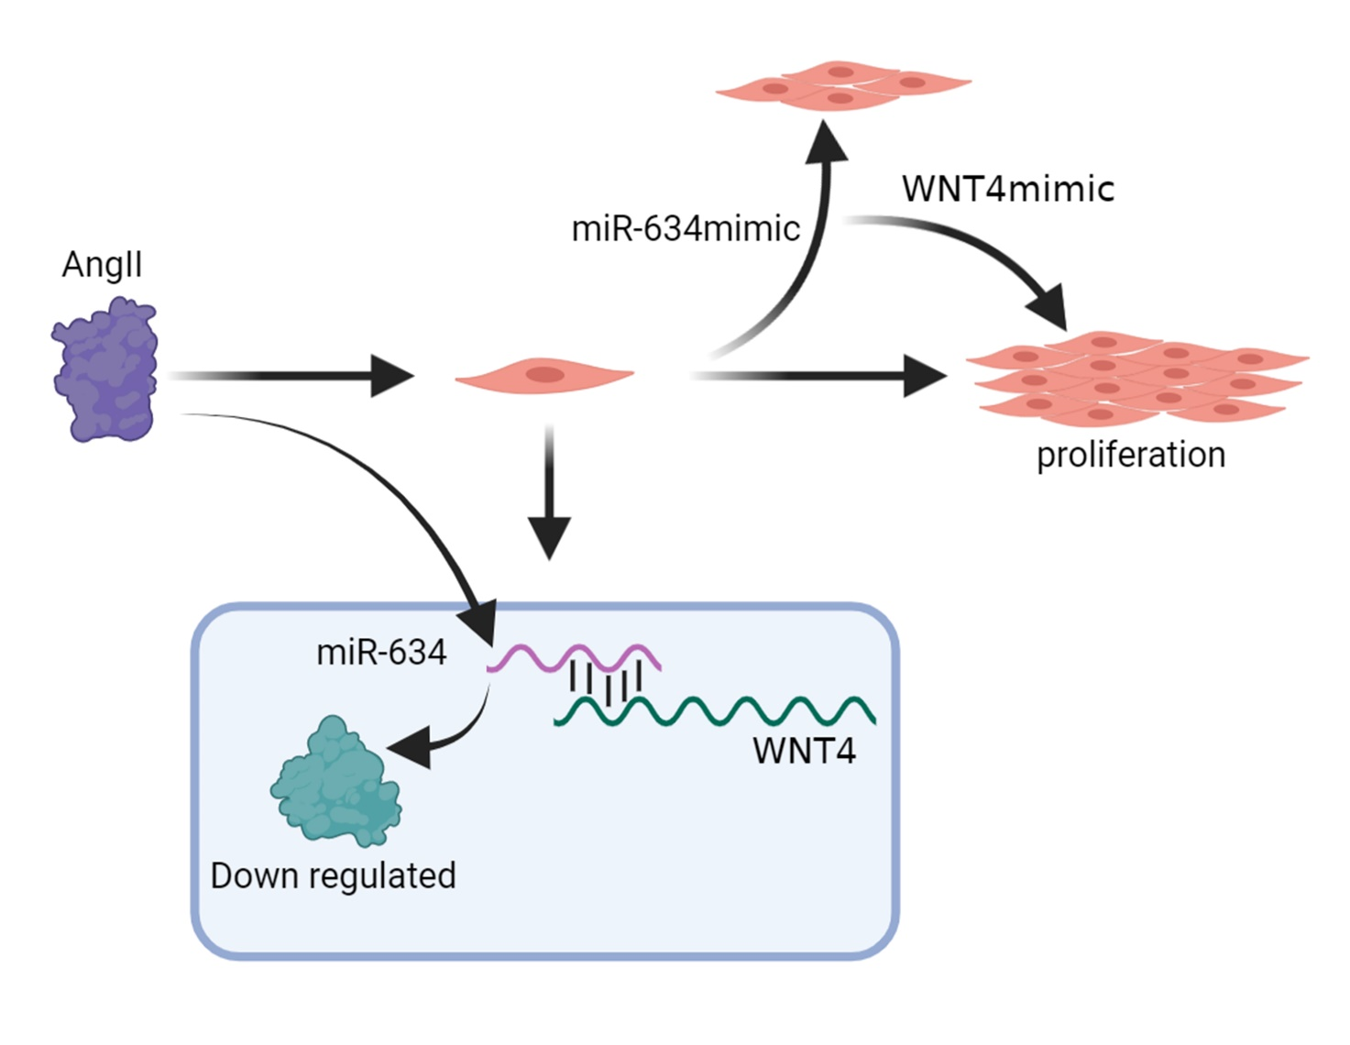
Supplementary Fig. 4. miR-634 functioned as a novel regulator of VSMCs proliferation and migration via inhibiting Wnt4/β-catenin pathway.

